# A

**Project Report On**

## Cab Management System

**By:** Kayum Parmar Semester – 6

# Project Guide:

PROF.



**Submitted To:** Geetanjali College of Computer Science and Commerce Rajkot.

# Academic Year:

2024-2025.

**ACKNOWLEDGEMENT**

I Am Happy to Submit My Idea Of " **Cab Management System** " Application In Saurashtra University, Rajkot For BCA Degree In Computer Branch.

We take this occasion to thank God, almighty for blessing us with his grace and taking our Endeavour to a successful culmination. We extend our sincere and heartfelt thanks to our esteemed guide, PROF. ………………. for providing us with the right guidance and advice at the crucial junctures and for showing us the right way. We would like to thank the other faculty members also, at this occasion. Last but not the least, we would like to thank friends for the support and encouragement they have given us during the course of our work.

# Index

|  |  |
| --- | --- |
| * Project Profile | 01 |
| * Introduction | 02 |
| * Software Environment | 04 |
| * Working Environment | 06 |
| * Diagrams | 07 |
| * Data Dictionary | 09 |
| * Screen Shots | 12 |
| * Implementation and Evaluation | 35 |
| * Future Enhancement | 36 |
| * Webliography | 37 |

**PROJECT PROFILE**

|  |  |
| --- | --- |
| Project Title | Cab Management System |
| Development Software | VS Code |
| Project Language | Python |
| Frontend Languages | HTML, CSS,  JavaScript, Bootstrap |
| Backend Languages | Django and MySQL |
| Documentation Tool | Microsoft Word |
| Operating System | Windows |
| Academic Year | 2024 – 2025 |
| Developed By | Kayum H. Parmar |
| Submitted To | Geetanjali College |

## **INTRODUCTION**

**Cab Management System:**

The Cab Management System is a web-based application designed to facilitate efficient cab booking and management. The system serves three primary stakeholders: customers, drivers, and administrators. Customers can book rides, view booking history, and provide feedback. Drivers can manage ride assignments and update ride statuses. Administrators oversee the entire system, including user management, and analytics.

**Admin Module :**

The Admin Module is a core component of the Cab Booking & Management System, providing administrators with a comprehensive dashboard and a range of management functionalities. The admin panel is designed to facilitate efficient Cab operations through the following features:

* **Dashboard** – Displays key metrics, system statistics, and recent activities for quick insights. Admins can monitor overall system performance here.
* **Manage Categories** – Allows admins to add, update, and delete categories for service organization. It ensures structured data management.
* **Cab Management** – Enables admins to manage cab details, including adding, updating, and deleting records. This helps in efficient fleet management.
* **View Booking** – Displays booking details for reference, allowing admins to view all reservations. No modifications can be made on this page.
* **List of Clients** – Shows registered clients with options to update or delete their details. Admins can maintain an up-to-date client database.
* **Admin Profile -** Offers profile display first name, last name, username and e-mail according who is login in.
* **Log Out -** Provides a secure option to log out of the system, ensuring data security and preventing unauthorized access.

**Driver Module:**

* **Dashboard** – Provides an overview of assigned rides, earnings, and notifications. Drivers can track their performance and upcoming trips.
* **View Bookings** – Displays a list of assigned bookings with details like pickup, drop-off, and time. Drivers can stay updated on their schedules.
* **Update Status** – Allows drivers to update ride status (e.g., Accepted, Ongoing, Completed). Helps in real-time trip tracking and customer updates.
* **Profile Management** – Enables drivers to update their personal information. Ensures records are accurate and up to date.
* **Log Out -** Provides a secure option to log out of the system, ensuring data security and preventing unauthorized access.

**User Module :**

* **Home Page** – Serves as the main landing page, showcasing services, features, and an easy-to-use ride booking option.
* **About Page** – Provides information about the company, its mission, values, and services to help users understand the platform.
* **Book a Ride** – Allows users to request a cab by entering pickup and drop-off locations with fare estimation.
* **View Bookings** – Displays a list of current and past bookings with ride details and status updates.
* **Profile Management** – Users can update their personal details, contact information, and preferences for a personalized experience.
* **Log Out -** Provides a secure option to log out of the system, ensuring data security and preventing unauthorized access.
* **User Registration Page** – Allows new users to create an account by providing necessary details such as name, email, password, contact and other information.
* **Login Page** – A common login portal for users, drivers, and admins, enabling secure authentication based on their role in the system

# SOFTWARE ENVIRONMENT

* **Technologies Used -**

1. **Python (Django Framework) -** Backend development framework used for building the Hotel Management System with robust features and scalability.
2. **HTML -** Markup language used for structuring the content and layout of web pages in the system.
3. **CSS -** Styling language used for designing and creating a visually appealing and responsive interface.
4. **JavaScript -** Client-side scripting language used for dynamic interactions and enhancing user experience on the web pages.
5. **Bootstrap -** Frontend frameworks used for creating responsive and modern designs with minimal effort.
6. **Laragon -** Laragon is a fast, lightweight local development environment supporting PHP, Node.js, and Python for easy server setup and project management.
7. **MySQL -** Databases used for storing and managing hotel data, bookings, and payment information.
8. **Django -** Django is a high-level Python web framework that enables rapid development of secure, scalable, and maintainable web applications.

* **Technologies Break Down –**

1. **Python (Django Framework) -**

Django is a high-level Python web framework that facilitates fast development of secure and maintainable web applications. It follows the Model-View-Template (MVT) architecture and provides built-in tools for database management, authentication, and routing, making it ideal for building the backend of the Cab Management System.

1. **HTML –**

HTML (Hypertext Markup Language) is the standard language for creating the structure and content of web pages. It forms the skeleton of the Cab Management System, organizing the content like text, images, links, and forms in a structured way for the user interface

1. **CSS –**

CSS (Cascading Style Sheets) is used to style the visual presentation of web pages. It controls aspects like layout, colours, fonts, and responsiveness, ensuring the Cab Management System has an attractive and user-friendly interface across different devices.

1. **JavaScript –**

JavaScript is a programming language that enables dynamic behavior on web pages, such as form validation, interactive maps, and content updates without reloading the page. It enhances the Cab Management System's interactivity, making the user experience smoother and more engaging.

1. **Bootstrap –**

Bootstrap is a popular open-source frontend framework that simplifies web design and development by providing pre-designed components like grids, buttons, and navigation bars. It helps create responsive, mobile-first web pages for the Cab Management System with minimal effort.

1. **Laragon** –

Laragon is a fast and lightweight local development environment that simplifies web development by providing essential tools like Apache, Nginx, MySQL, and more in a single package. It supports multiple technologies such as **PHP, Node.js, Python**, and others, allowing developers to easily set up and manage local servers for testing and development.

1. **MySQL –**

MySQL is a relational database management system used to store and manage data in the Cab Management System. It efficiently handles data related to bookings, customer details, cab availability, and ensuring reliable data storage and retrieval.

1. **Django –**

Django is a high-level Python web framework that enables rapid development of secure, scalable, and maintainable web applications. It simplifies backend development with built-in tools for database management, security, and user authentication, making it an ideal choice for building the Cab Management System.

**SYSTEM REQUIREMENT**

#### Hardware Configuration:

Processor : intel i3

RAM : 4 RAM

Hard Disk Drive : 20 GB

Monitor : 15’6’’ HD Display

Display Type : VGA

#### Software Configuration:

Operating System : Windows 11 , or any other

Web server : Apache

Web Browser : Chrome/Edge

Designing Tool : HTML

Server Side Scripting : Django

Client Side Scripting : MYSQL

# DIAGRAMS

**Data Flow Diagram –**



**ER Diagram –**

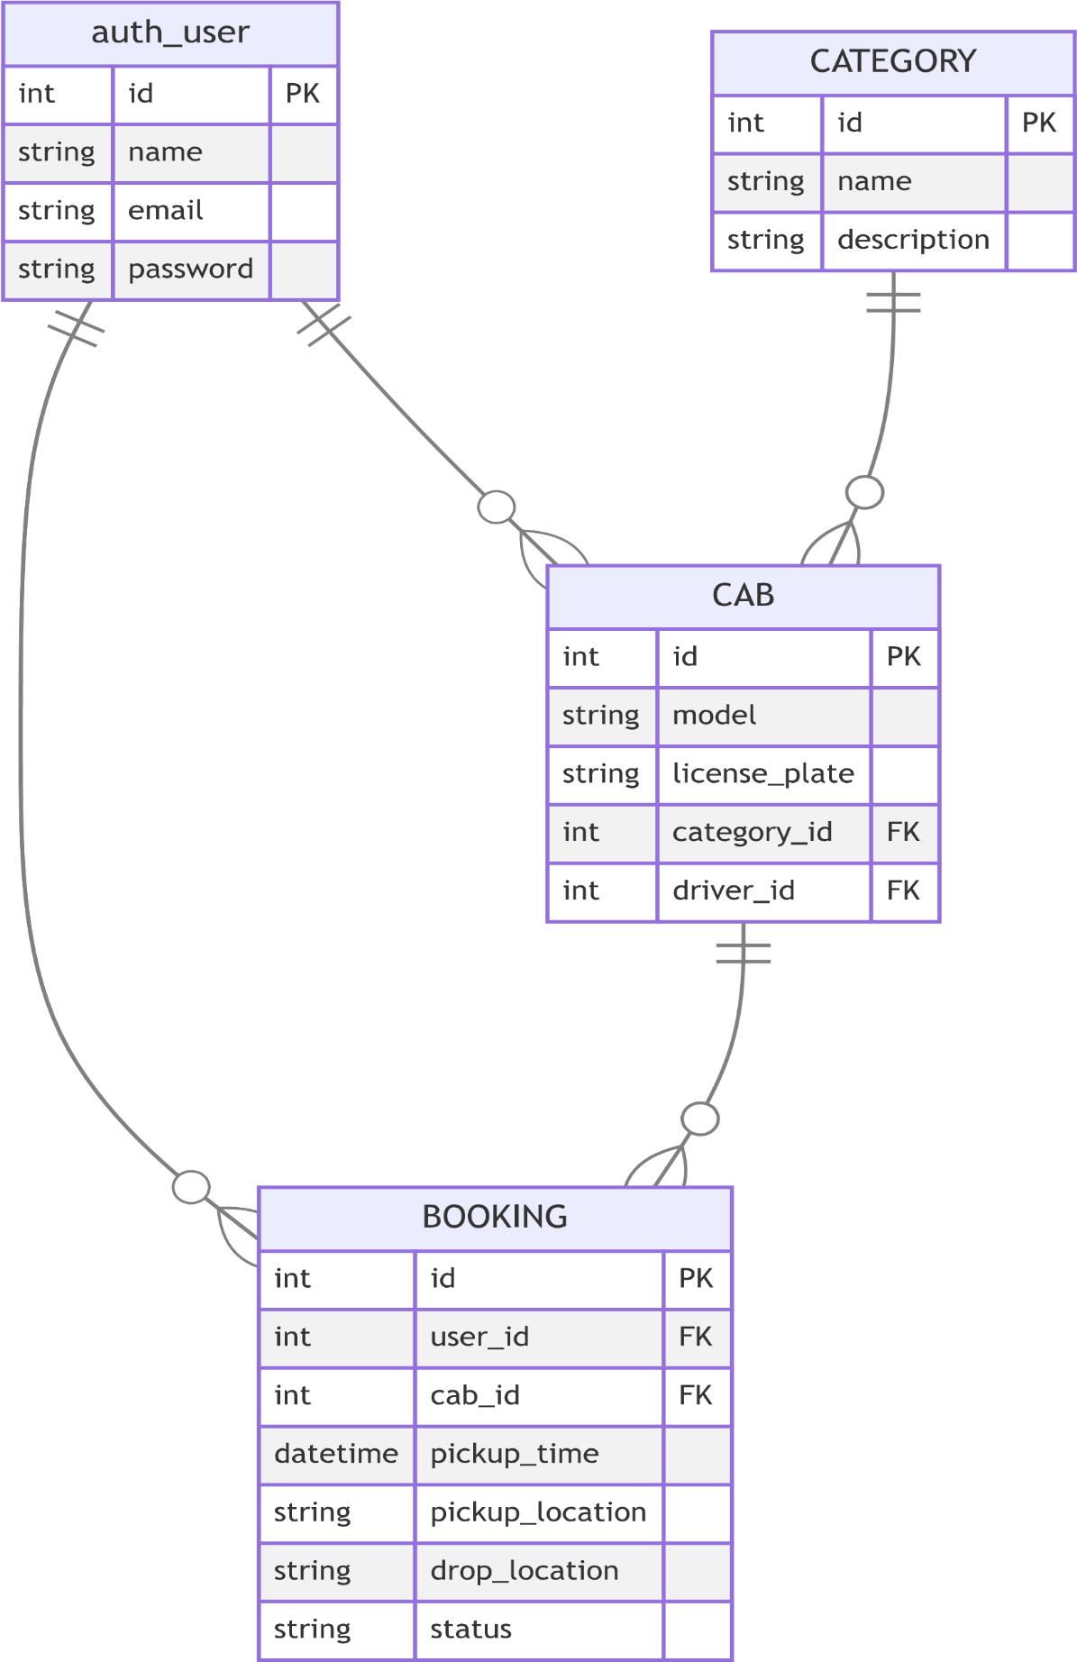

# DATA DICTIONARY

### Auth_user:

|  |  |  |  |  |  |  |
| --- | --- | --- | --- | --- | --- | --- |
| # | **Name** | **Type** | **Collation** | **Null** | **Default** | **Extra** |
| 1 | **id** | int(11) |  | No | None | AUTO_INCREMENT |
| 2 | **password** | varchar(50) | utf8mb4_general_ci | Yes | None |  |
| 3 | **last_login** | datetime(6) |  | No | NULL |  |
| 4 | **is_superuser** | tinyint(1) |  | No | None |  |
| 5 | **username (FK)** | varchar(50) | utf8mb4_general_ci | No | None |  |
| 6 | **first_name** | varchar(50) | utf8mb4_general_ci | No | None |  |
| 7 | **last_name** | varchar(50) | utf8mb4_general_ci | No | None |  |
| 8 | **email** | varchar(50) | utf8mb4_general_ci | No | None |  |
| 9 | **is_staff** | tinyint(1) |  | No | None |  |
| 10 | **is_active** | tinyint(1) |  | No | None |  |
| 11 | **date_joined** | datetime(6) |  | No | None |  |

**Mainsite_userprofile:**

|  |  |  |  |  |  |  |
| --- | --- | --- | --- | --- | --- | --- |
| # | **Name** | **Type** | **Collation** | **Null** | **Default** | **Extra** |
| 1 | **id** | int(11) |  | No | None | AUTO_INCREMENT |
| 2 | **gender** | varchar(50) | utf8mb4_general_ci | No | None |  |
| 3 | **address** | varchar(50) | utf8mb4_general_ci | Yes | Null |  |
| 4 | **contact** | varchar(11) | utf8mb4_general_ci | Yes | Null |  |
| 5 | **image_path** | varchar(50) | utf8mb4_general_ci | Yes | Null |  |
| 6 | **user_id (FK)** | int |  | Yes | Null |  |

**mainsite_categories :**

|  |  |  |  |  |  |  |
| --- | --- | --- | --- | --- | --- | --- |
| # | **Name** | **Type** | **Collation** | **Null** | **Default** | **Extra** |
| 1 | **id** | int(11) |  | No | None | AUTO_INCREMENT |
| 2 | **Name(FK)** | varchar(50) | utf8mb4_general_ci | No | None |  |
| 3 | **description** | longtext | utf8mb4_general_ci | Yes | NULL |  |
| 4 | **status** | varchar(50) |  | No | None |  |

|  |  |  |  |  |  |  |
| --- | --- | --- | --- | --- | --- | --- |
| # | **Name** | **Type** | **Collation** | **Null** | **Default** | **Extra** |
| 1 | id | int(11) |  | No | None | AUTO_INCREMENT |
| 2 | **cab_reg_no** | varchar(50) | utf8mb4_general_ci | No | None |  |
| 3 | **cab_model** | varchar(10) | utf8mb4_general_ci | No | None |  |
| 4 | **body_no** | varchar(50) | utf8mb4_general_ci | No | None |  |
| 5 | **driver_contact** | varchar(50) | utf8mb4_general_ci | No | None |  |
| 6 | **driver_address** | longtext | utf8mb4_general_ci | No | None |  |
| 7 | **driver_image** | varchar(50) | utf8mb4_general_ci | No | None |  |
| 8 | **Status** | varchar(50) | utf8mb4_general_ci | No | None |  |
| 9 | **category_id (FK)** | bigint |  | No | None |  |
| 10 | **driver_id (FK)** | int |  | No | None |  |

**mainsite_cab :**

|  |  |  |  |  |  |  |
| --- | --- | --- | --- | --- | --- | --- |
| # | **Name** | **Type** | **Collation** | **Null** | **Default** | **Extra** |
| 1 | id | int(11) |  | No | None | AUTO_INCREMENT |
| 2 | **ref_code** | varchar(50) | utf8mb4_general_ci | No | None |  |
| 3 | **pickup_zone** | longtext | utf8mb4_general_ci | No | None |  |
| 4 | **drop_zone** | longtext | utf8mb4_general_ci | No | None |  |
| 5 | **status** | int |  | No | None |  |
| 6 | **booking_date** | datetime(6) |  | No | None |  |
| 7 | **updated_date** | datetime(6) |  | No | None |  |
| 8 | **cab_id (FK)** | bigint |  | No | None |  |
| 9 | **client_id (FK)** | bigint |  | No | None |  |

**Mainsite_booking:**

## **SCREEN SHOTS**

## **Admin Panel:**

**Dashboard:**

* in this page show the total of the
  + Categories ,
  + Cabs ,
  + Registered Client ,
  + Booking made
  + Panding Booking
  + Cancelled Bookings
  + Ongoing trips
  + Trips Completed

**Manage Categories:**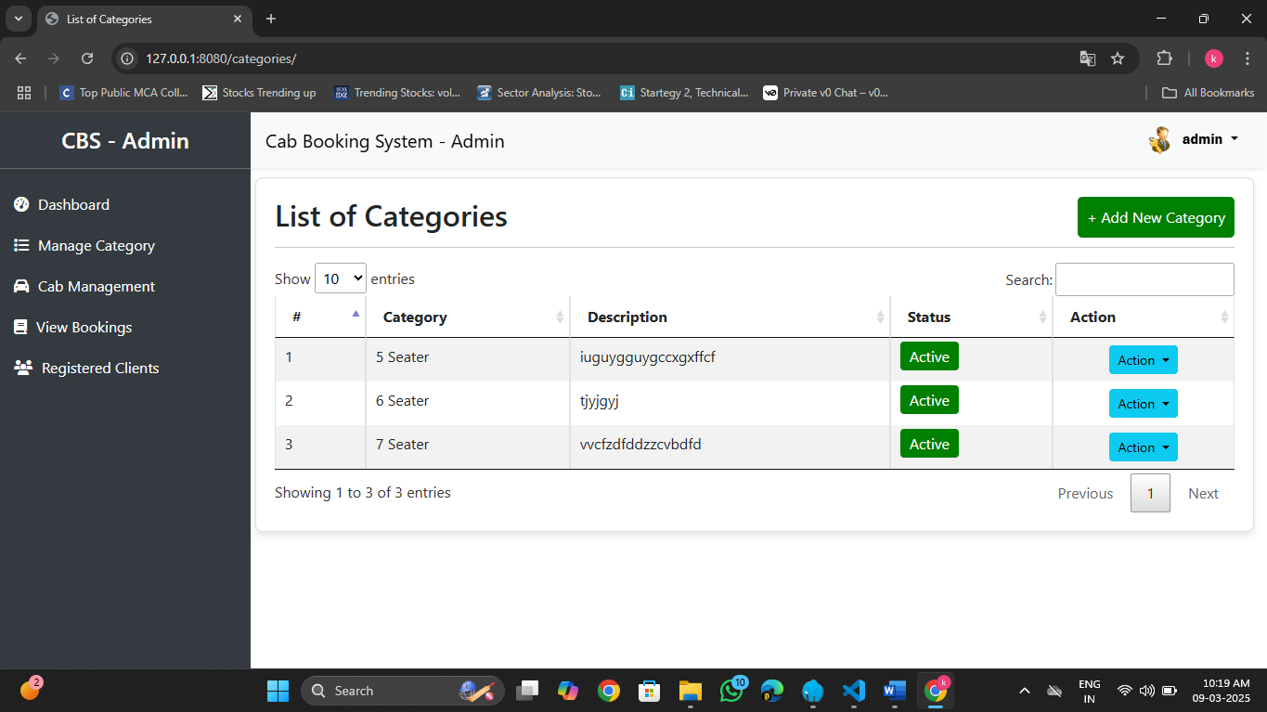

In this page manage the categories :

* This page is the List of Categories
* Also add the categories in the like 5 seater car
* Also update and delete the categories

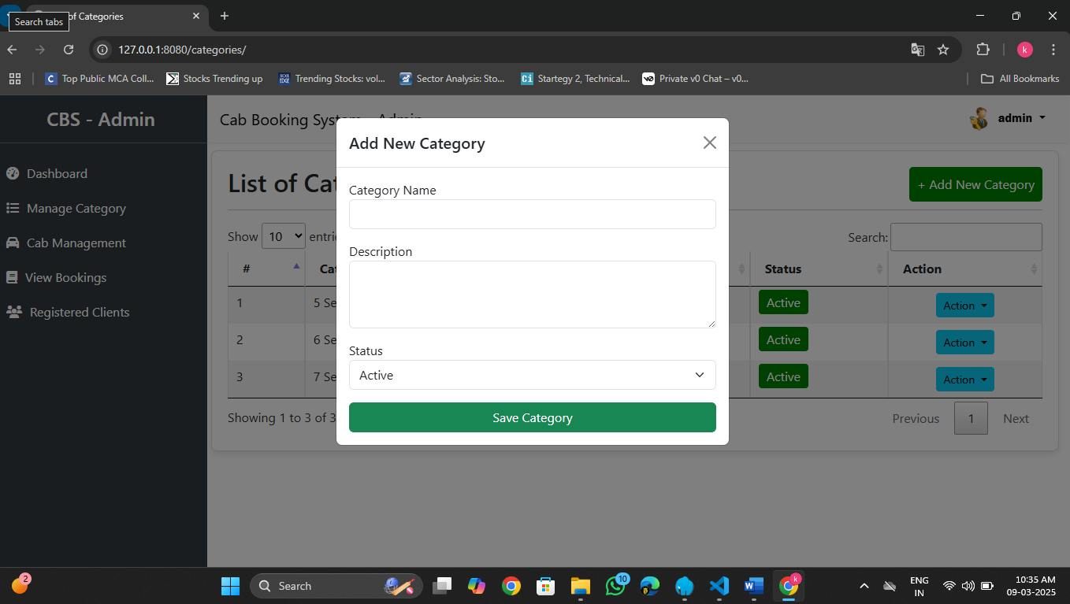**Add Categories:**

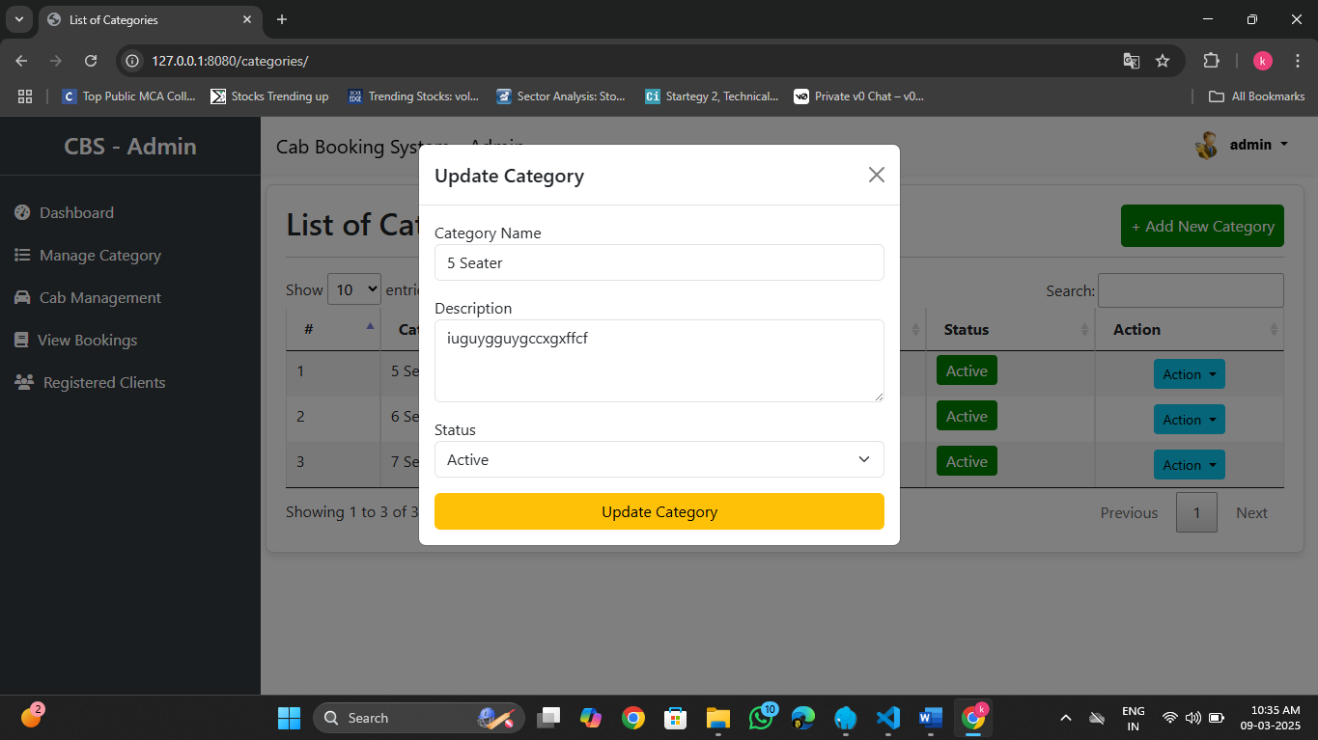**Update Categories:**

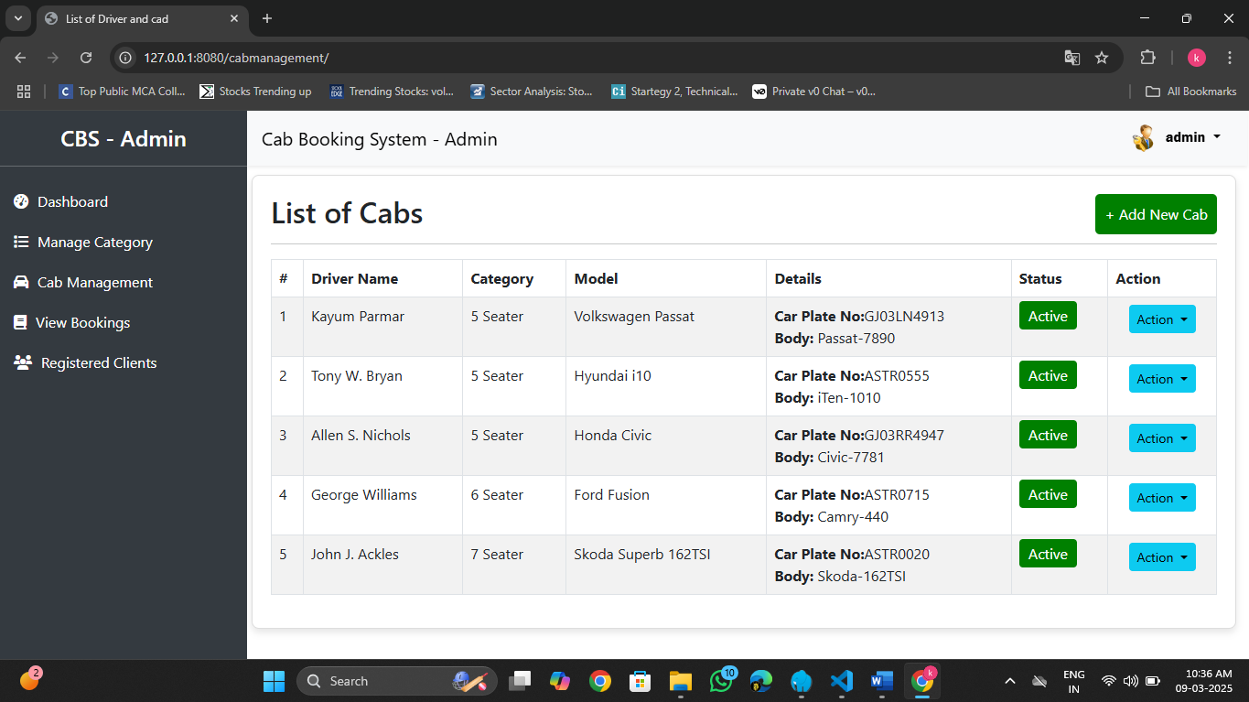**Cab management:**

In this page manage cab and driver :

* In this page list of the cab and their details
* Also add the cab in this page
* In the action admin can update the cad detail and driver details
* Also delete the cab

**Add the Cab:**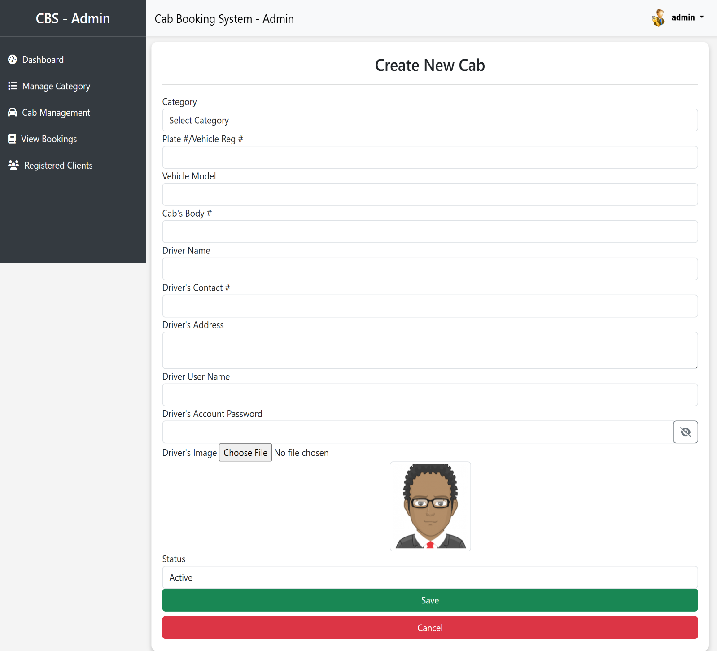

* Here add the cab by the admin

**Edit the cab:**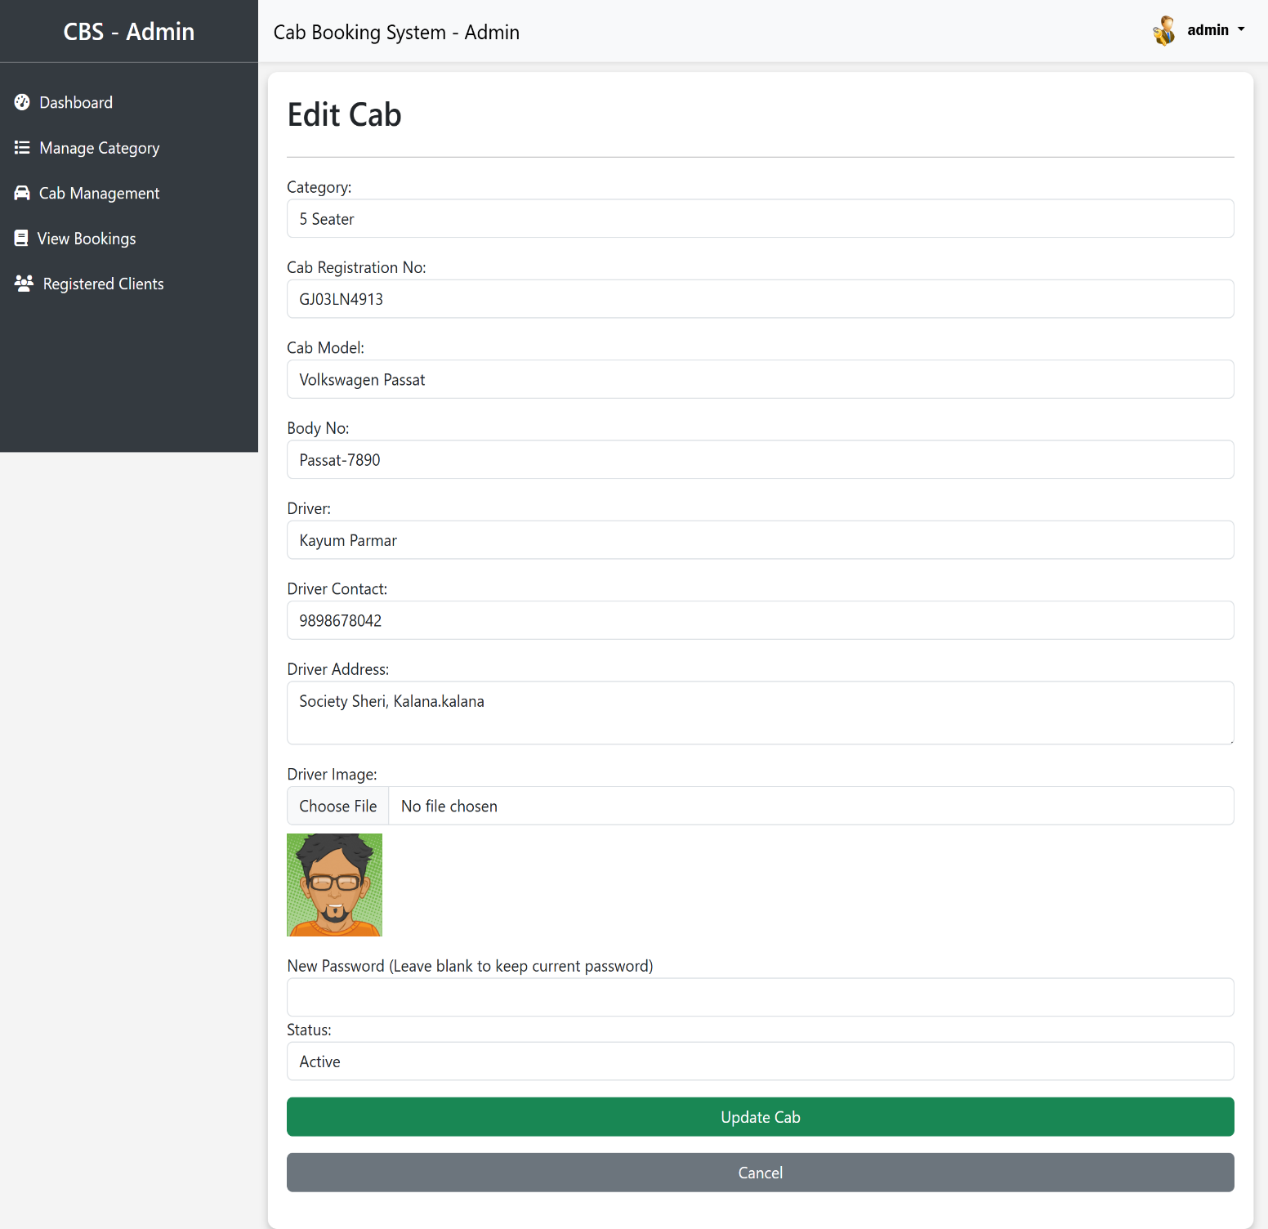

Here edit the cab details by the admin.

**List of the booking:**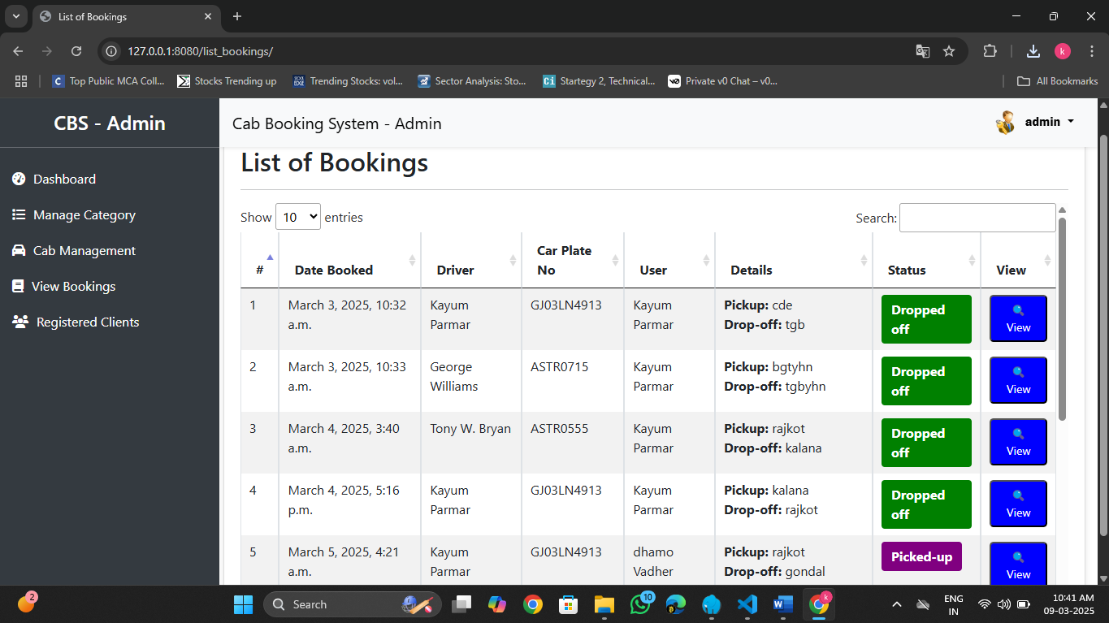

* Here show the list of the booking booked by the user
* In this page show the user and driver booking details.
* Show the status user is pick up or dropped by the driver
* Click on the view to show the all the information about the driver and user.

**View the information about the booking:**

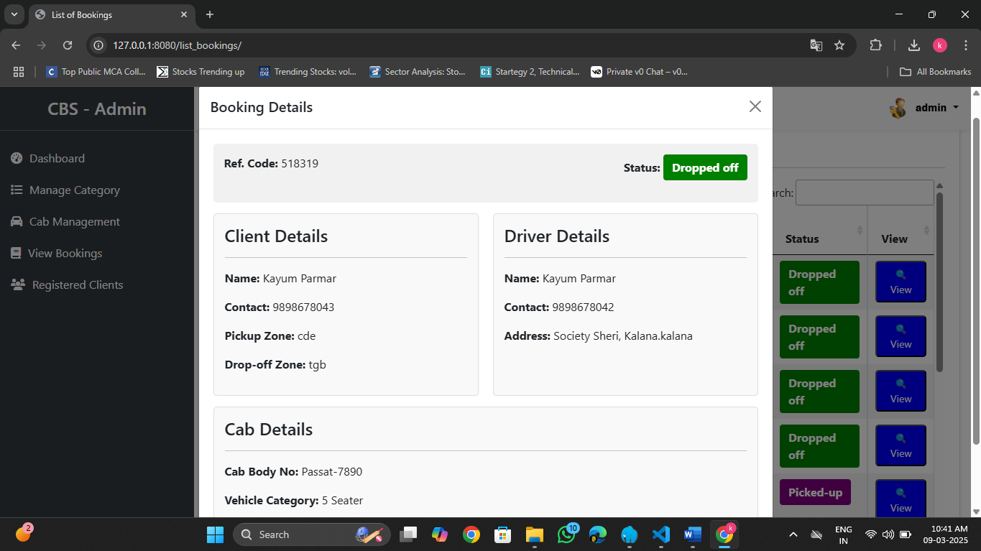

* Click on the view to show the all the information about the driver and user.

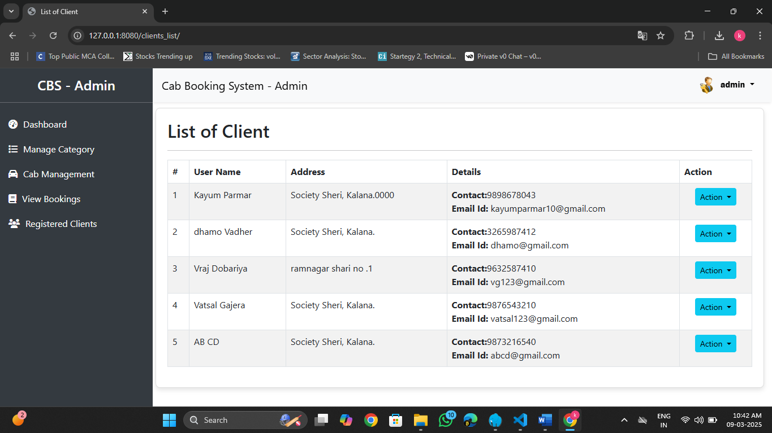**Registered clients:**

* In this page show the list of the client
* In the click in the action button also update and delete the client
* Show the all details of the client

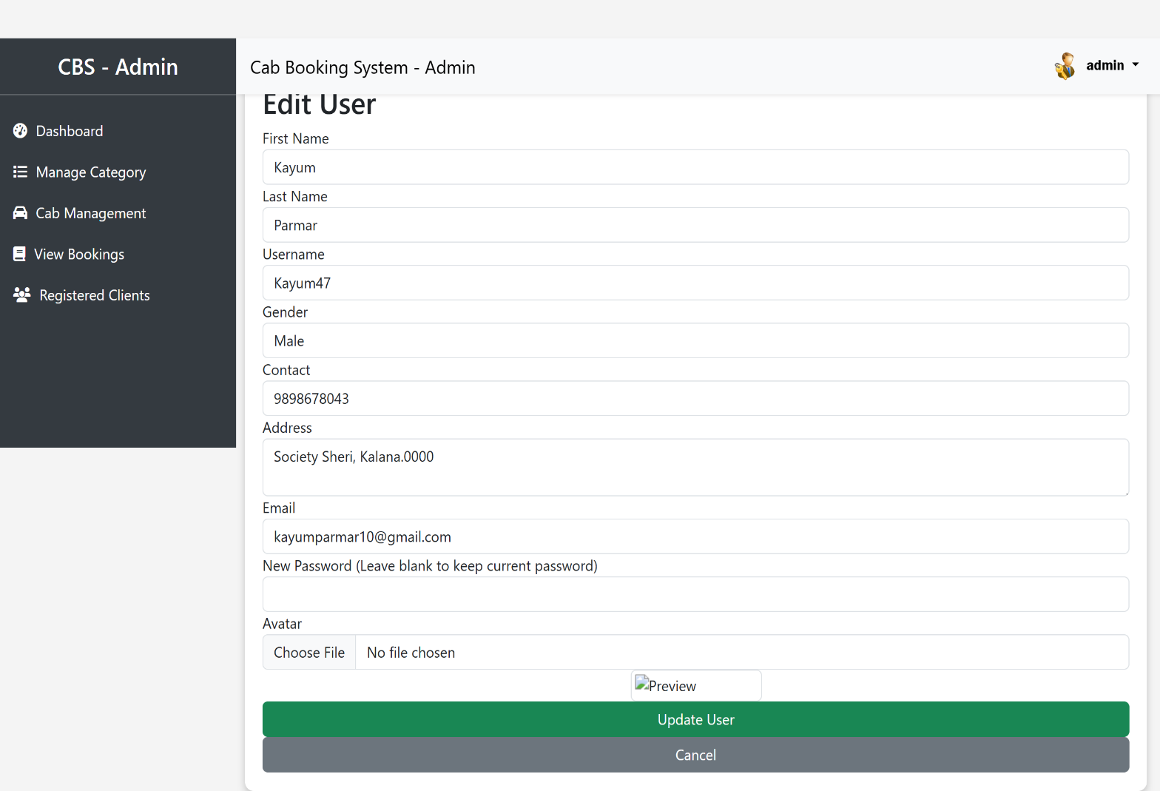**Update the client :**

* In this page edit the user by the admin

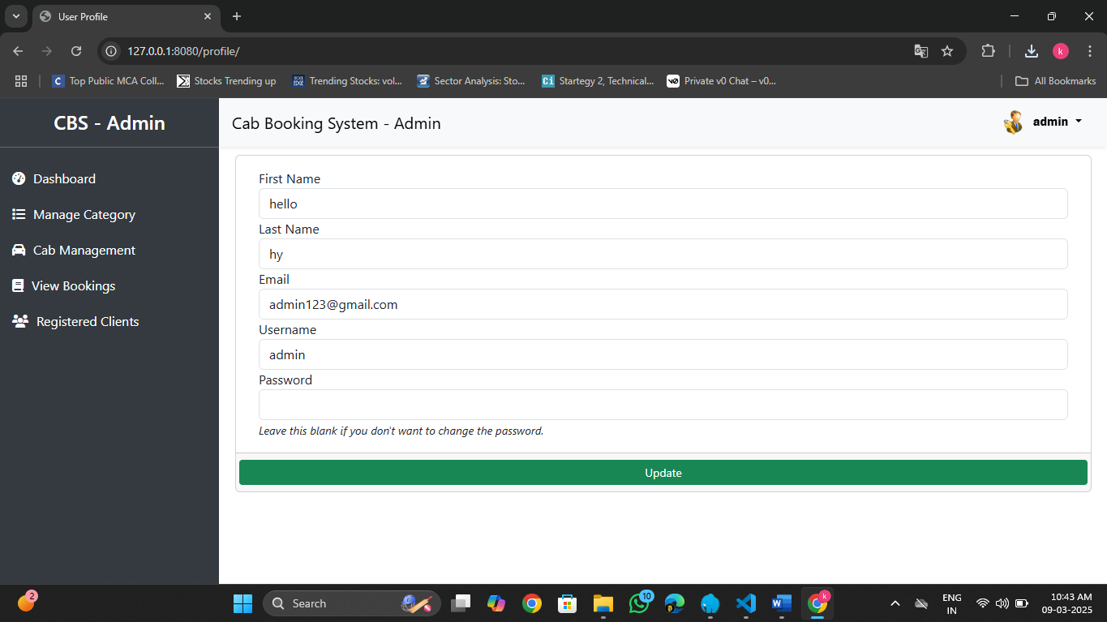**Admin profile :**

* This page is the admin profile
* Admin update their profile
* And also has the logout button

**Driver panel :**

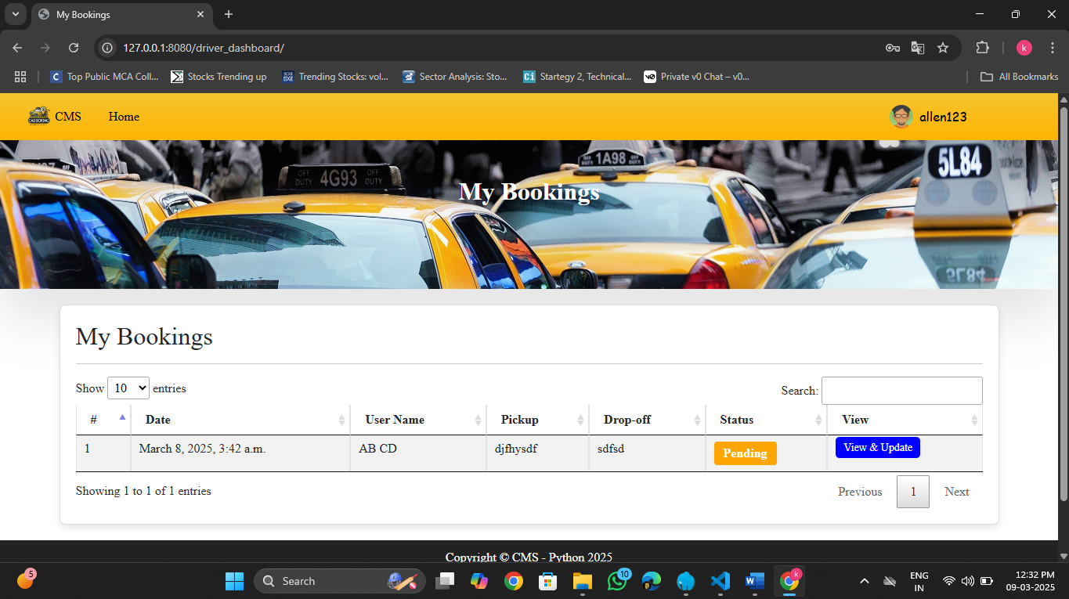**Driver dashboard :**

* This is the driver dashboard
* This page show the cab booked by the user
* Driver also conforms the booking

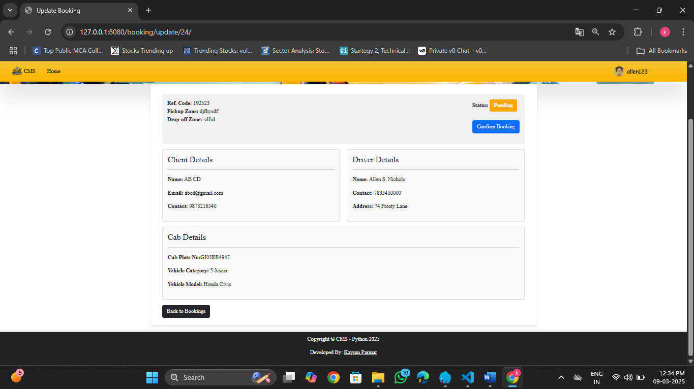**Update the booking status :**

* In this page driver conform the booking in this page by the driver
* Also update the pick up the user and user drop off by the driver  
  and also show booking pick up location and drop location

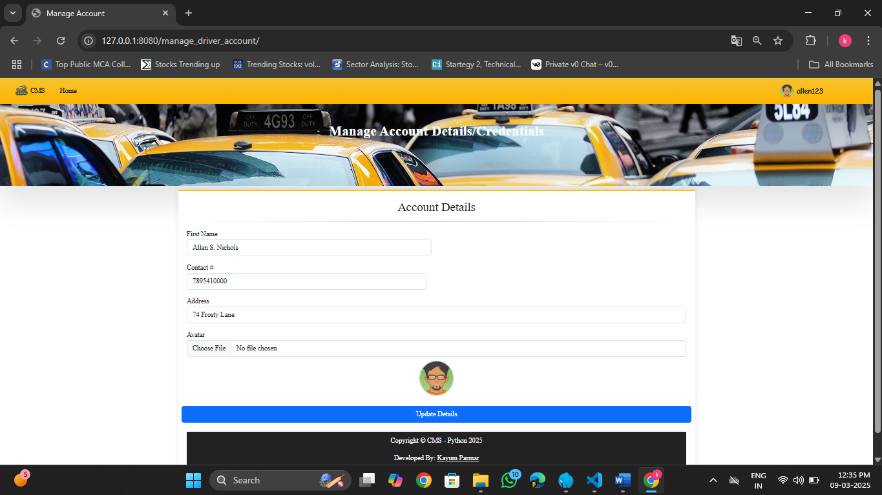**Driver profile :**

* Driver update the their profile
  + name
  + contact
  + email
  + address
  + profile photo

**User model:**

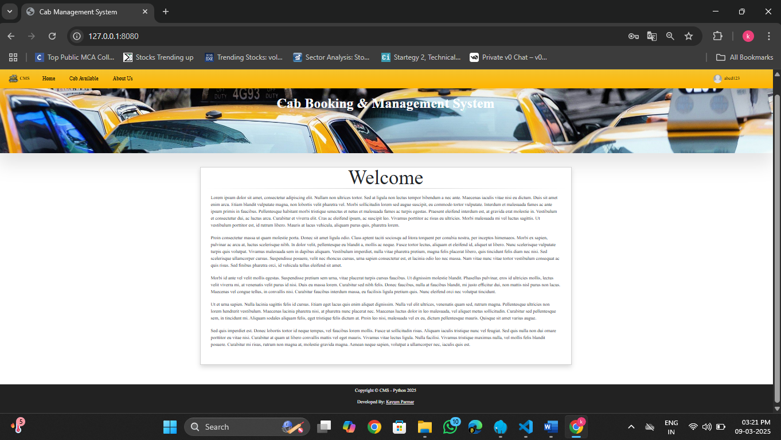**Home page :**

* This home page.

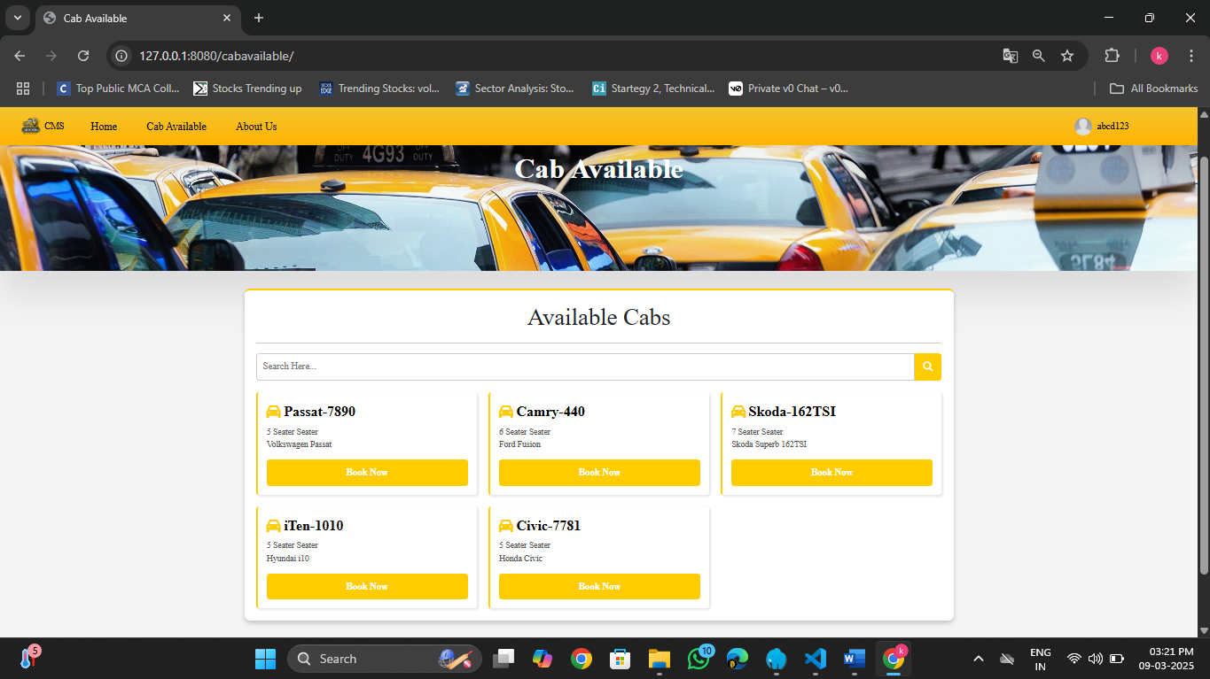**Booking page :**

* When user is the login then the user will book available cab
* Click on the book cab button .

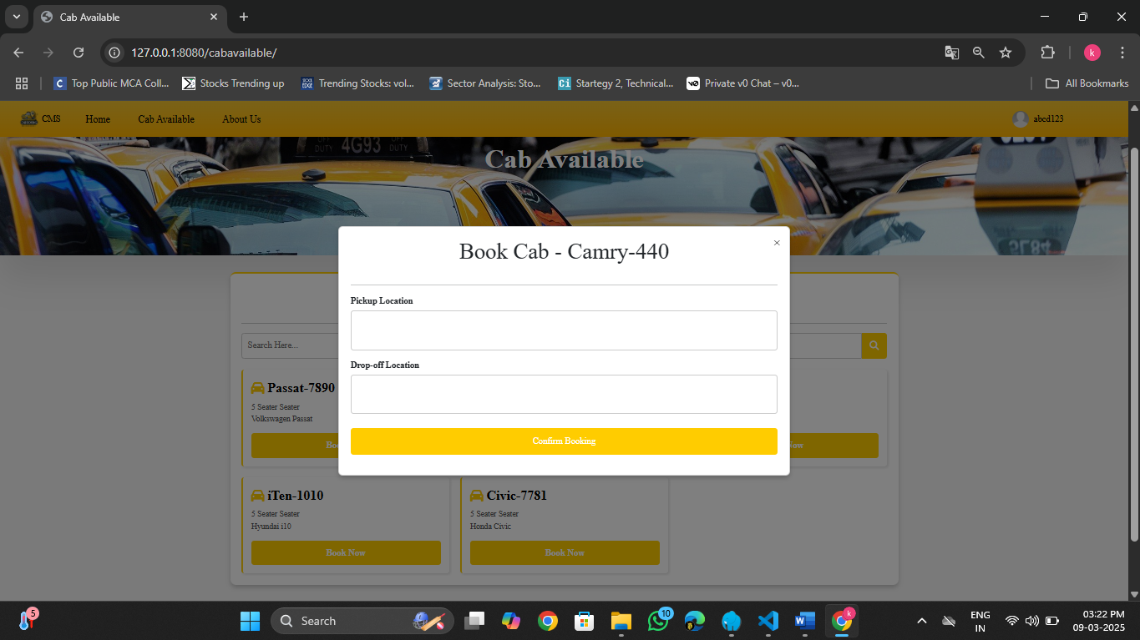**Booking form :**

* When user will click on the book cab button then
* Show the booking form
* User enter their pickup location and drop location
* Then click the conform booking

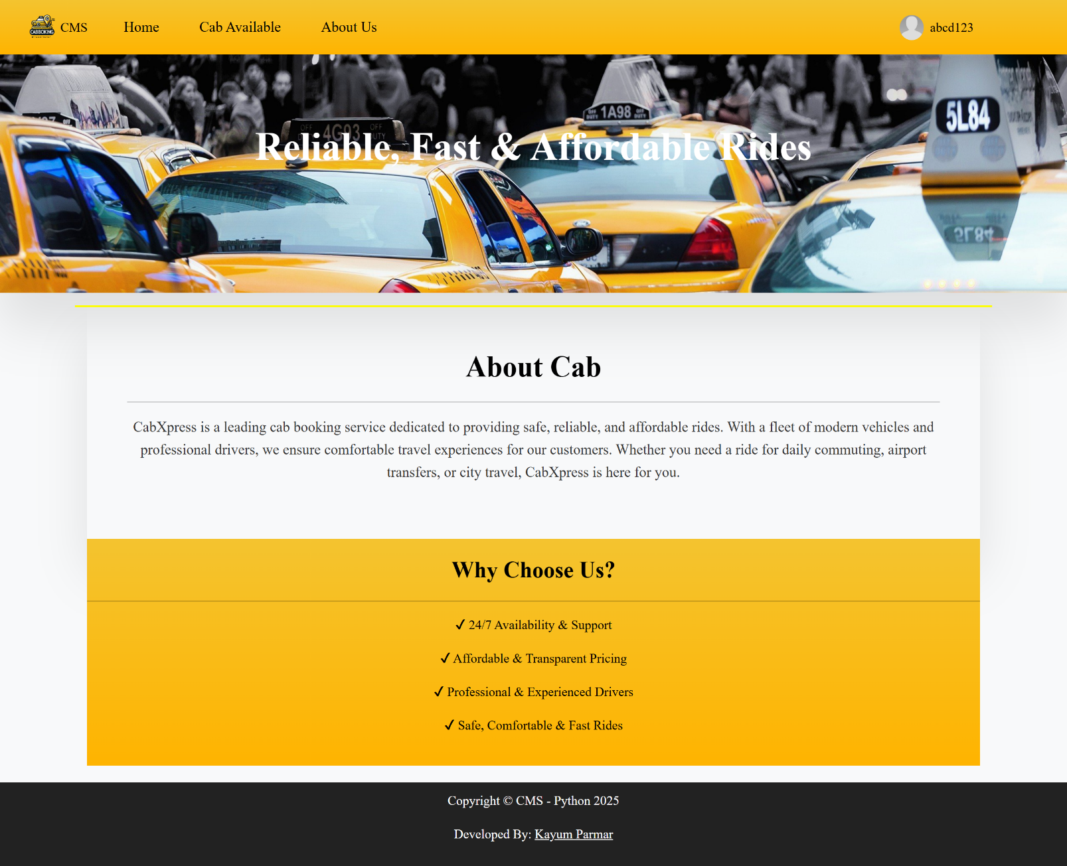**About us page:**

**User booking :**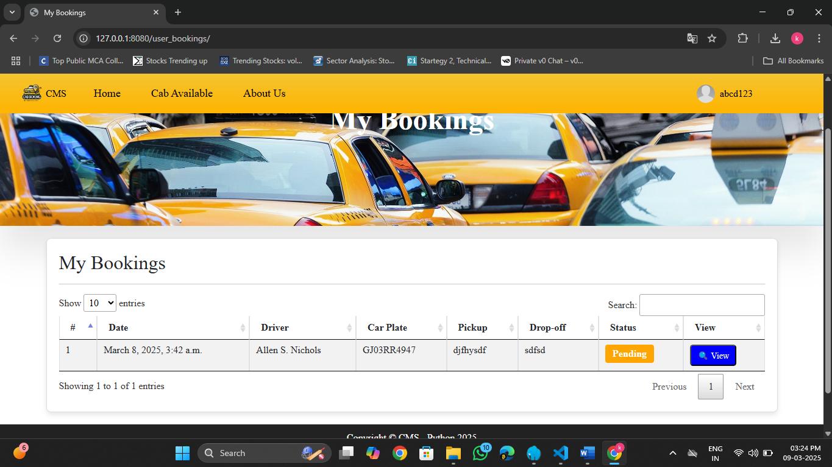

* + This is show user booking list
  + User show booking details and update status

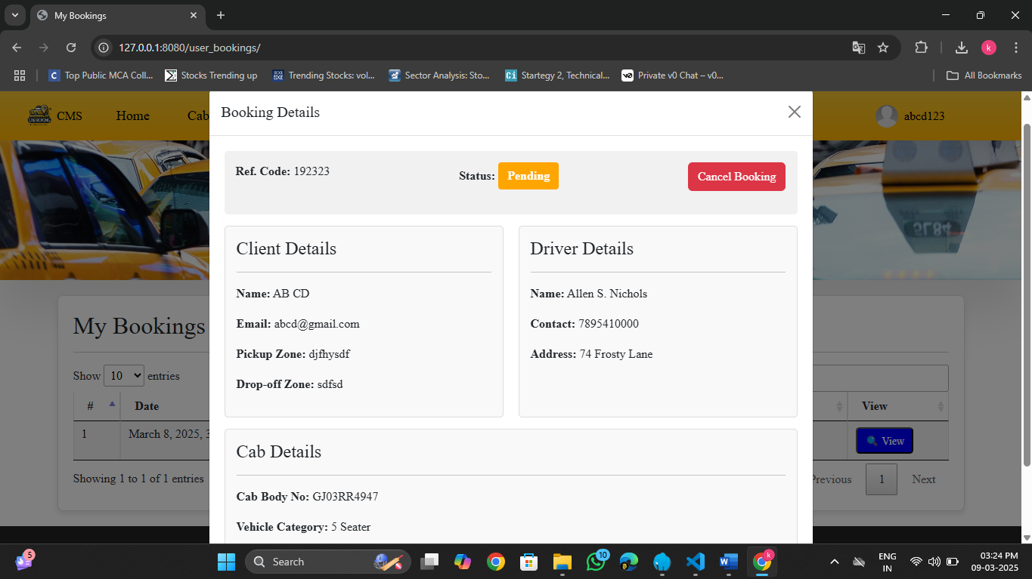**View the booking:**

* Click on the view button then show the full details of driver and user
* User also cancel the booking

**User profile :**

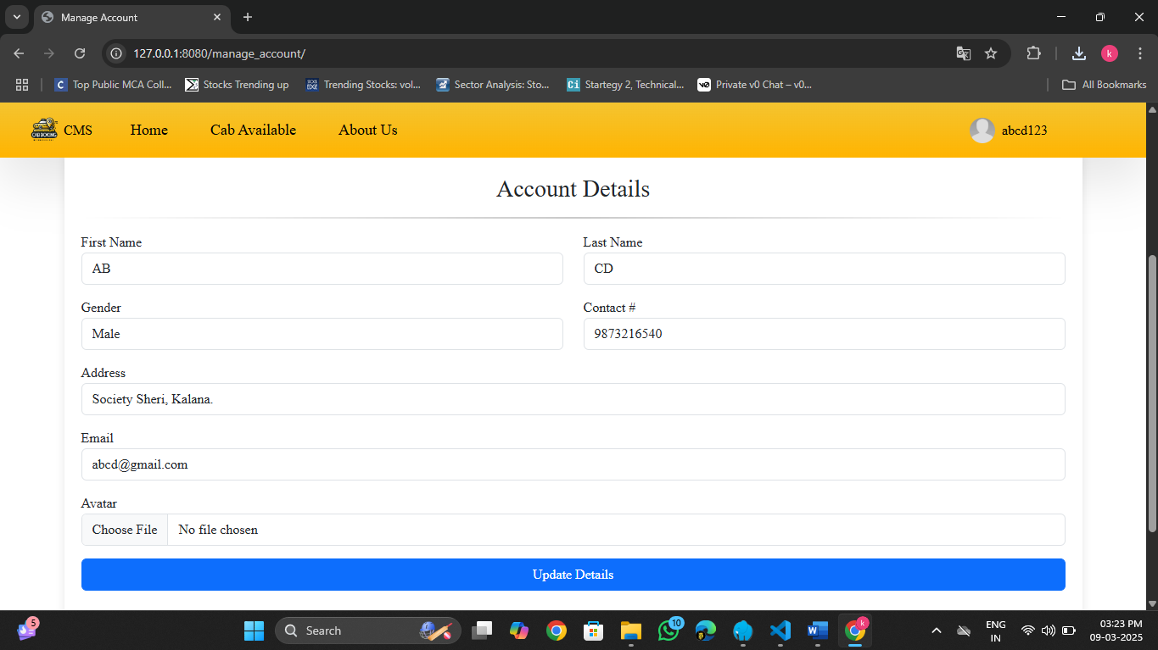

* User update their profile

**Registration form :**

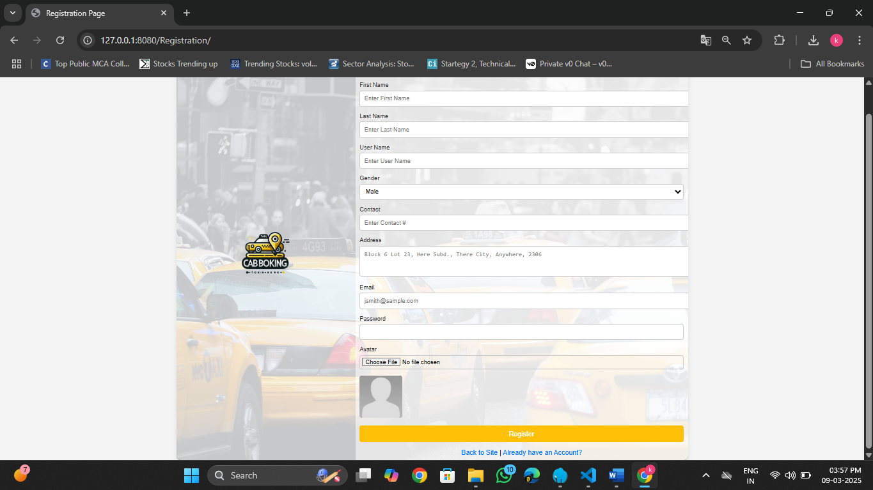

* User can register here for the site

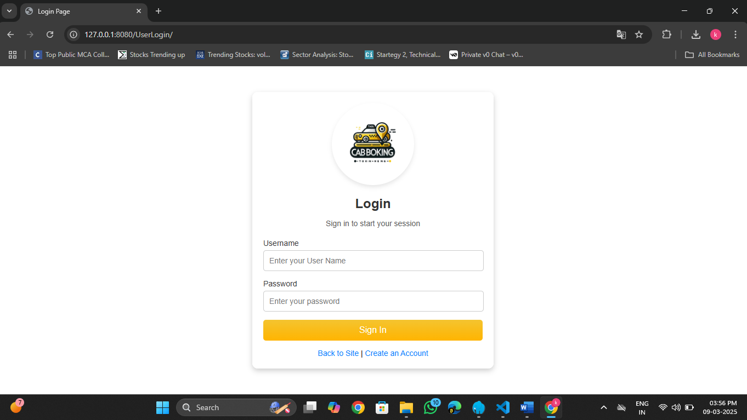**User login :**

* User, admin, driver login here

**IMPLEMENTATION AND EVALUATION**

**Implementation**

* Developed using Django for backend, PostgreSQL for database, and Google Maps API for location tracking.
* Secure user authentication with email/password login and OAuth (Google, Facebook) integration.
* Booking system allows users to schedule rides, track drivers in real-time, and estimate fares dynamically.
* Drivers can accept or reject ride requests, update availability, and navigate using in-app maps.
* Integrated multiple payment options, including Stripe, Razorpay, and PayPal, for seamless transactions.

**Evaluation**

* Functional testing ensures smooth booking, ride tracking, and payment processing.
* Performance testing optimizes database queries and API response times for faster execution.
* Security measures include CSRF protection, encrypted transactions, and role-based access control.
* Usability testing improves UI/UX for better navigation and mobile responsiveness.
* Deployed on cloud servers (AWS/Heroku) with real-time monitoring for error handling and updates.

**Future Enhancement:**

1. **AI-Based Fare Estimation**

Implement machine learning algorithms to analyze traffic patterns, demand fluctuations, and weather conditions for dynamic fare pricing.

1. **Subscription Plans**

Offer membership or subscription plans for frequent users with benefits like discounted fares and priority booking.

1. **Real-Time Driver Tracking & ETA Prediction**

Improve GPS tracking and integrate predictive algorithms to provide more accurate estimated arrival times (ETA).

1. **Cashless & QR Code Payments**

Enable cashless payments via QR codes, allowing users to scan and pay directly from their preferred payment app.

1. **Driver Tips & Donations**

Provide an option for users to tip drivers digitally or donate to a cause through the app.

1. **Electric & Hybrid Vehicle Options**

Promote sustainable travel by introducing an option to book electric or hybrid vehicles.

**WEBLIOGRAPHY**

#### Referring online manual from website

* [**https://docs.python.org/**](https://docs.python.org/)
* [**https://docs.djangoproject.com/**](https://docs.djangoproject.com/)
* [**https://dev.mysql.com/doc/**](https://dev.mysql.com/doc/)
* [**https://stackoverflow.com/**](https://stackoverflow.com/)